**ATTENDANCE RECORDER**

**A Mini-Project Report**

**Under**

**Implementation of Technology**

***Submitted by***

**MONIL JAIN**

**MIHIR PATEL**

**KAJOL RATHOD**

**ANIKET KOTHARI**

***in partial fulfillment for the award of the degree***

***of***

**B.TECH**

**IN**

**COMPUTER SCIENCE**

**At**



**MUMBAI**

**APRIL 2015**

**CERTIFICATE**

This is to certify that the project entitled ATTENDANCE RECORDERis the bonafide work carried out by MONIL JAIN, MIHIR PATEL, KAJOL RATHOD, ANIKET KOTHARI B.Tech (Computer Engineering), MPSTME (NMIMS), Mumbai, during the fourth semester of the academic year 2014-2015, in fulfillment of the requirements for the award of the Degree of Bechelors of Technology as per the norms prescribed by NMIMS. The project work has been assessed and found to be satisfactory.

_______________________ ________________________

Examiner 1 Examiner 2

________________________

Dean

Dr. S.Y. Mhaiskar

**DECLARATION**

We, MONILJAIN, MIHIR PATEL, KAJOL RATHOD, ANIKET KOTHARIB.Tech (Computer Engineering), semester- IV, understand that plagiarism is defined as anyone or combination of the following:

1. Un-credited verbatim copying of individual sentences, paragraphs or illustration (such as graphs, diagrams, etc.) from any source, published or unpublished, including the internet.

2. Un-credited improper paraphrasing of pages paragraphs (changing a few words phrases, or rearranging the original sentence order)

3. Credited verbatim copying of a major portion of a paper (or thesis chapter) without clear delineation of who did wrote what.

4. We have made sure that all the ideas, expressions, graphs, diagrams, etc., that are not a result of our work, are properly credited. Long phrases or sentences that had to be used verbatim from published literature have been clearly identified using quotation marks.

5. We affirm that no portion of my work can be considered as plagiarism and we take full responsibility if such a complaint occurs. We understand fully well that the guide of the seminar/ seminar report may not be in a position to check for the possibility of such incidences of plagiarism in this body of work.

Signature of the Students:

___________ ____________ ___________ ____________

Name: ___________ ____________ ___________ ____________

Roll No. ___________ ____________ ___________ ____________

Place: Mumbai

Date: April 2015

**ACKNOWLEDGEMENT**

We would like to show our gratitude towards Poonam maám who helped us whenever we required assistance. We would also like to acknowledge the reviewers of our app who by understanding our concept and idea gave corresponding positive and negative feedbacks which helped us improve our app accordingly.

At the end we would like to thank our respected HOD sir and Dean sir without whose consent and warm support we would have not got the opportunity to learn with such efficiency.

**Table of Content**

**Sr. No. Topic Page No.**

List of figures i

Abstract ii

# **1. Introduction**

## 1.1 Problem Specification 1

## 1.2 Solution Outline 2

## 1.3 Application/Usage 3

# **2. System Analysis**

## 2.1 Existing System (If any) 4

## 2.2 Software Requirement 4

## 2.3 Hardware Requirement 4

# **3. Design and Methodology**

## 3.1 Flowchart of App 5

## 3.2 Output (Screenshot of the app) 7

## 3.3 Limitation of App 11

# **4. Conclusion and Future Scope** 12

# **5. References** 13

**LIST OF FIGURES**

**FIG. NO. TITLE PAGE**

1 App first page 7

2 Add course option 7

3 Add course page 8

4 Main Page 8

5 Attendance calculating page 9

6 Attendance calculating page [updated] 9

7 Date picker 10

8 Delete course option 10

i

**ABSTRACT**

This project involves discovering our ability and potential under implementaion of technologies [IOT]. Here we have tried to bridge our knowledge with emerging technology by acquiring some application development skills on the android platform which is the widest source available today.

We have tried to develop an interactive and simple android attendance tracker application that will help the students of various fields to keep an accurate note of their attendance. This has been done by clearly examining the various problems and situations faced by students during their college life.

This app looks at a way to resolve the attendance problems by simply providing the users to feed in their subjects with respective attendance criteria. Then the user just needs to press the buttons whenever he attends or misses any class and his attendance will be calculated and displayed automatically. The app also provides the user with the expected attendance [assuming that the user does not bunks any more classes], so that they have a clear idea about how many more classes they need to attend.

The simple user interface makes it easy and convenient to use the app neglecting any complexities.

ii

**1] INTRODUCTION**

**1.1] PROBLEM SPECIFICATIONS:**

Since we entered this college world, it has been a normal sight to see students calculating their attendances. Many of us note down the number of lectures we have attended on the last page of our books and count the number of lectures that we still need to attend to complete the attendance criteria. We have ourselves done many times. So we came up with this idea.

We thought of something that would eliminate this problem of ours and help us bunk lectures more accurately.So our main problem was to keep an accurate update of the number of lectures that have been attended and those that one still needs to attend to keep up with the minimum attendance percentage criteria.

1

**1.2] SOLUTION OUTLINE:**

We created an android application that would calculate the students attendance and help them know the number of lectures that they still need to attend to cope up with the attendance criteria.So the students can feed in their subjects and the minimum attendance required in each of them. Next they just need to update the app whenever a lecture is conducted. And their attendace is then just a click far.

Along with the current attendance the app also informs them about their estimated attendance at the semester end. The solution demands a simple and attractive user-interface that does not over complicate the desired outcome.

2

**1.3] APPLICATION/USAGE:**

Coming to the application part of this app, the choice of feeding the subjects at their own convenience is given so that the app is not limited in any way. It can have wide range of users and a student of any stream can use this app easily. Also this app allows the user to feed different attendance crireria for different subjects as per ones need.The users can add a new subject or delete the existing ones at any time easily. Also it gives the user an option to separate the lab classes and theory classesto avoid confusion.

Not limiting this app to just students, this can be utilized by even teachers or anyone who wants to track his/her attendance. The future scope promises to add an homework or assignment section which will enable the students to add any pending work.

3

**2] SYSTEM ANALYSIS**

**2.1] EXISTING SYSTEMS:**

Threre are many number of attendance applications on android that might help you do these calculations. But none of them are user friendly. Either they are filled with number of complex usages that are of no use or they just do the calculation.

Our app on other hand is quite user friendly and easy to use . It deals with the basic main agenda rather than just being eye appealing by redundant graphs and statistics in existing systems.

**2.2] SOFTWARE REQUIREMENT:**

Our application works on all android devices with android version 2.2 and above.

**2.3] HARDWARE REQUIREMENTS:**

This application will require 1.2 MB of space to get installed in a device. The size may increase later on usage of the app [In case of large data stored which is not significantly high.]

4

# **3] DESIGN AND METHODOLOGY**

**3.1] FLOWCHART OF THE APP:**

So we Begin the usge of the app by adding the courses detail that we need to track.We feed in the required data about the subjects and there are few main functions of this app that define the basic structure of the flowchart:

Add a course- Add the subject name and required attendance

Edit a course- Edit the data that you have provided about the app

Calculate attendance of a course- calculate the current and estimated attendance of a particular subject

Delete a course- delete a subject from you app data.

5

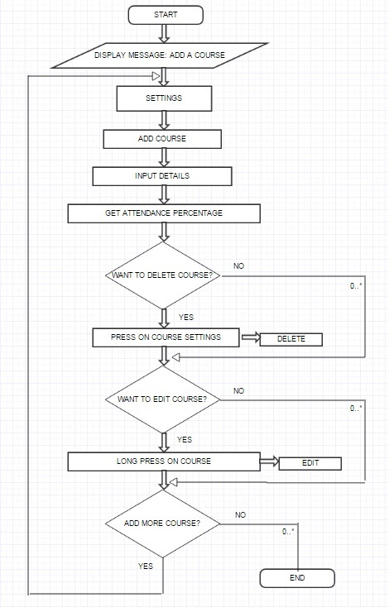

6

**3.2] OUTPUT [SCREENSHOTS]:**

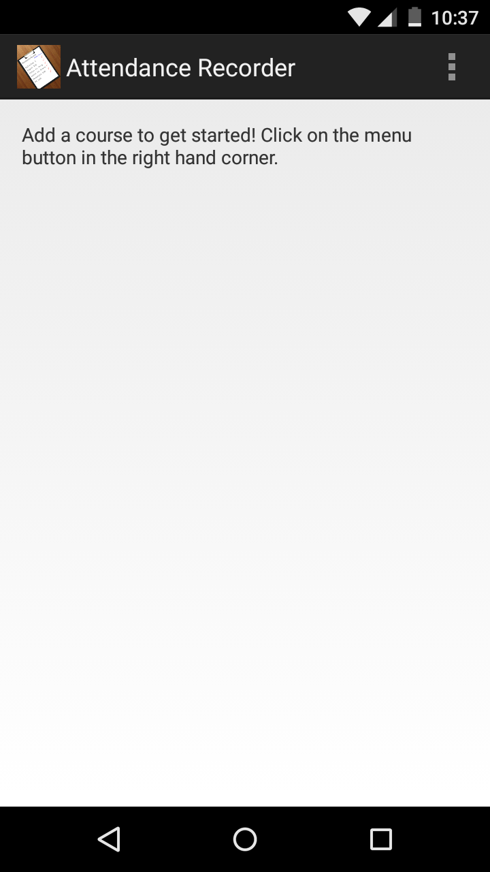 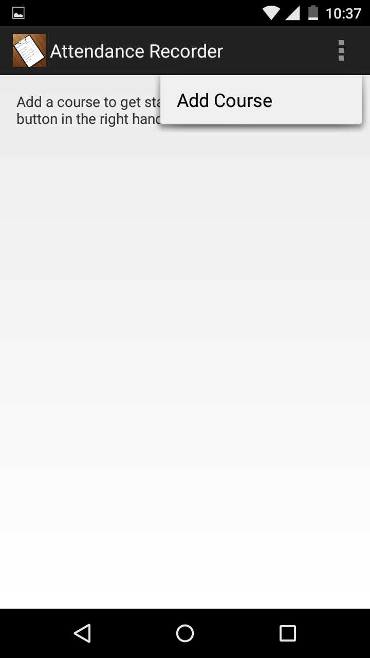

1 2

7

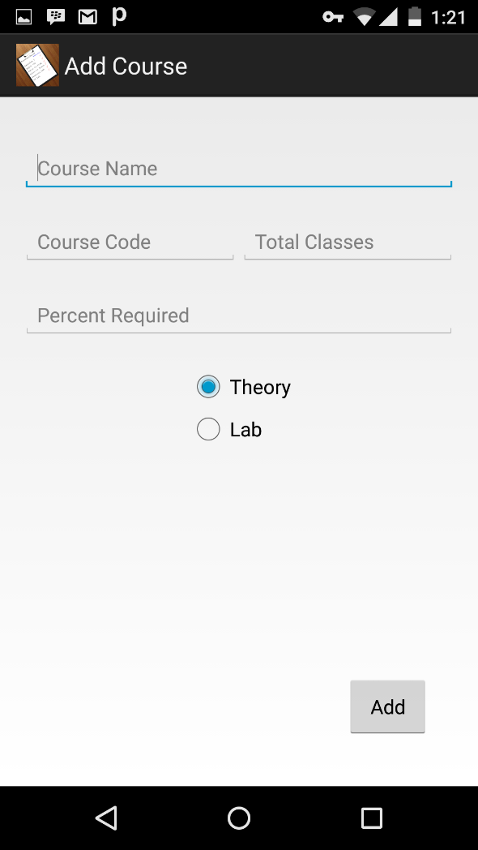 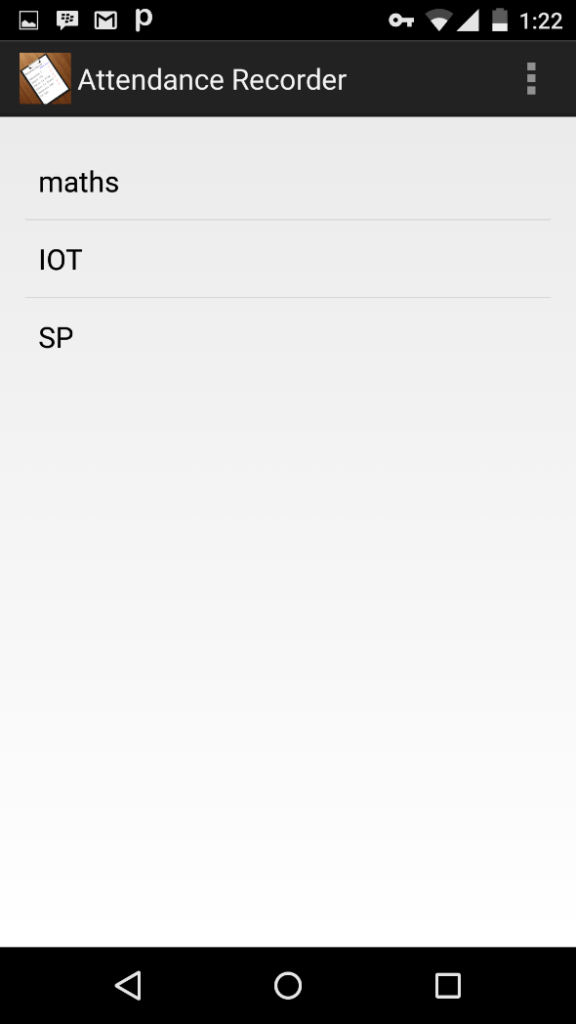

3 4

8

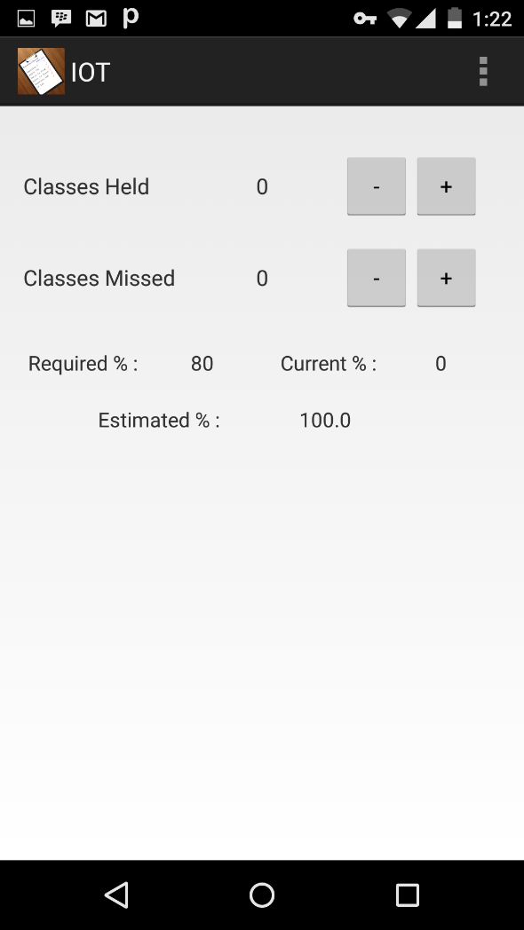 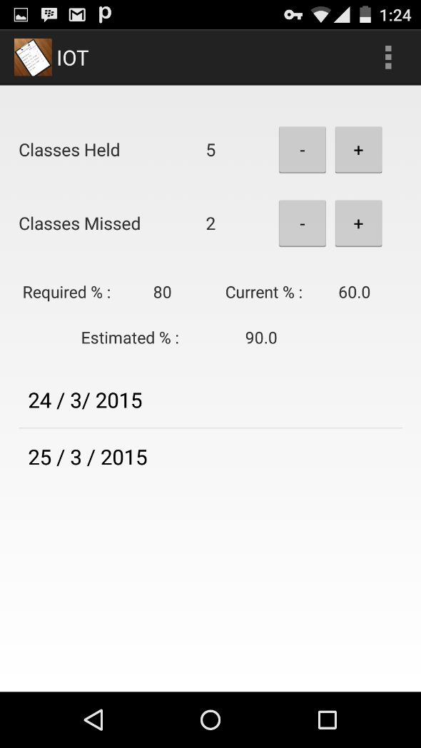

5 6

9

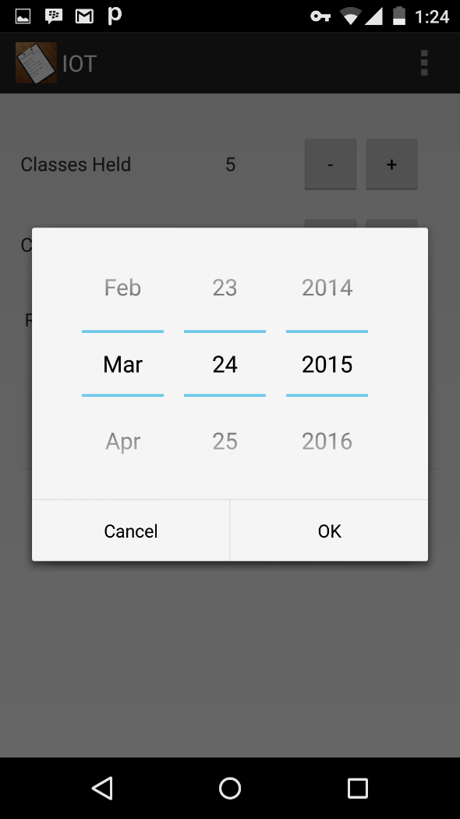 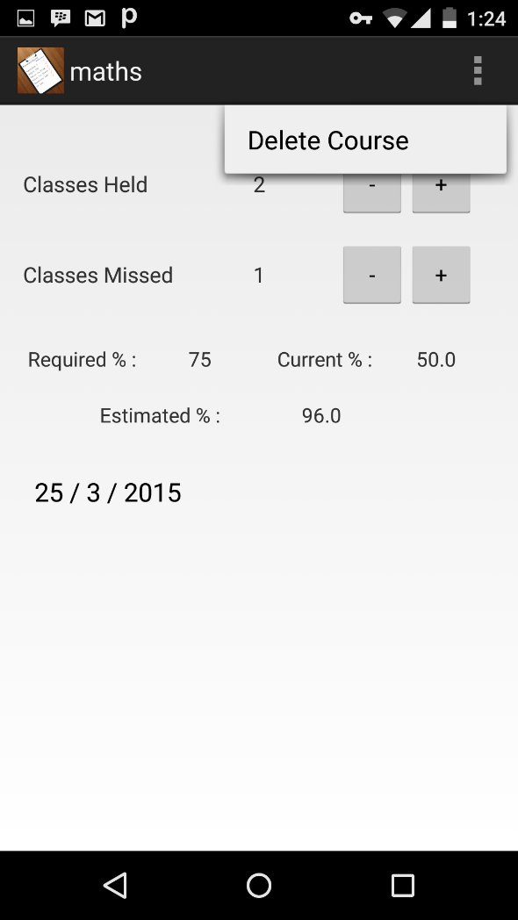

7 8

10

**3.3] LIMITATIONS OF APP:**

The app does not work on time table basis. So everytime a lecture is conducted the user is expected to inform it to the app as it does not comes to know on its own.[Which is possible if we work on time table basis]. If the user forgets to update the app when he attends the lecture, then the calculations will not be accurate.

Also our app functions on devices with android version 2.2 and above only.

11

**4] CONCLUSION AND FUTURE SCOPE**

We would conclude by saying that we have tried our best to come up with a good app that can sum up all the problems related to attendance faced by a student and makes their life a bit easy.

Considering the future scope , we are planning to add an homework section to the subjects.So the students will also be able to keep a note about their pending assignments.

12

**5] REFERENCES**

[1] GOOGLE

[2] YOUTUBE

13